
Alliance School of Advanced Computing Master of Computer Application

PROGRAM: Master of Computer Application
Title: Stock exchange prediction

SUBJECT: Mastering Python-From Basics to Advanced

SEMESTER: I

ACADEMIC YEAR: 2026-2028

Submitted to: Mr. Kushal I Huddar
Submitted by:
BasavanaGowda – PROV/ASAC/MCA/7/26/084 Darshan HD– PROV/ASAC/MCA/7/26/085
Sunil K – PROV/ASAC/MCA/7/26/014

DECLARATION

We hereby declare that the group case study entitled “Stock exchange prediction” is an original work prepared by our group as part of the academic requirements for Discrete Structure at Alliance University.
The work has been completed under the guidance of Mr. Kushal I Huddar All information and sources used have been appropriately acknowledged and referenced.
We further declare that this work has not been submitted, in whole or in part, for any other academic award or assessment, except were permitted by the institution.

Date: 25/10/2026

Group Members: Approved by: Mr. Kushal I

- BasavanaGowda Subject Co-ordinator

- Darshan HD Master of Computer Application

- Sunil K Alliance University

ACKNOWLEDGEMENT

We would like to express our sincere gratitude to Kushal I Huddar, for providing us with the opportunity to undertake this group case study on “Stock exchange prediction” Their valuable guidance, encouragement, and constructive suggestions have been instrumental in completing this work successfully.
We extend our heartfelt thanks to our institution and department for providing the necessary resources and academic support throughout the preparation of this case study.
We would also like to acknowledge the efforts and cooperation of all our group members. Their teamwork, dedication, and exchange of ideas helped us analyze the problem, explore possible solutions, and gain valuable practical knowledge.
Finally, we thank everyone who directly or indirectly contributed to the successful completion of this case study.

TABLE OF CONTENTS

Section | Indicative page
Declaration | I
Acknowledgement  1. Abstract | II  1-2
2. Introduction  3, Aim and Objects  4. Results  5.Conclusion | 3-5  6-7  8-10  11-12

1.ABSTRACT:
Financial market prediction remains one of the most challenging pursuits in quantitative finance due to the inherent non-linearity, high volatility, and stochastic nature of stock exchanges. Traditional forecasting models often fall short in capturing complex temporal dependencies and external macroeconomic sentiment. This study proposes an advanced predictive framework that integrates [insert model types, e.g., Long Short-Term Memory (LSTM) networks and Transformer architectures] with [insert supplementary data source, e.g., natural language processing (NLP)-based sentiment analysis of financial news and social media]. By jointly processing historical time-series pricing data and real-time market sentiment, the proposed model aims to enhance directional accuracy and mitigate noise-induced false signals. Empirical evaluations across [insert markets/indices, e.g., NSE, NYSE, or S&P 500] demonstrate that the hybrid approach significantly outperforms traditional baseline models in predicting [insert target, e.g., short-term price movements / intraday volatility]. These findings offer valuable insights for algorithmic trading strategies, automated portfolio management, and risk mitigation in volatile financial environments.
Keywords: Stock Market Prediction, Deep Learning, Time-Series Forecasting, Sentiment Analysis, Transformer Models, Quantitative Finance.

Core Elements Breakdown:
- Context & Motivation: Establishes the complexity and volatility of financial markets.
- Problem Statement: Identifies the limitations of legacy technical and fundamental forecasting techniques.
- Proposed Methodology: Details the combination of deep learning architectures with alternative data streams (such as news sentiment).

Evaluation & Impact: Summarizes expected performance gains and real-world utility for algorithmic traders and risk managers.
1. Primary Research Objectives
- Objective 1: Evaluate the efficacy of sequence-to-sequence deep learning models (e.g., LSTMs, Transformers) over traditional econometric models (e.g., ARIMA) in capturing non-linear market behaviors.
- Objective 2: Quantify the impact of alternative data streams—specifically real-time NLP sentiment analysis from financial news and social media—on short-term price movement forecasts.
- Objective 3: Construct an automated backtesting framework to assess risk-adjusted returns (e.g., Sharpe Ratio, Maximum Drawdown) under simulated live-market constraints.

2. Recommended Methodology Pipeline
- Data Acquisition: Gather historical trade metrics (Open, High, Low, Close, Volume) alongside unstructured text data from financial news or regulatory filings.
- Feature Engineering:
  - Technical Indicators: Relative Strength Index (RSI), Moving Average Convergence Divergence (MACD), and Bollinger Bands.
  - Sentiment Scoring: Polarity and confidence scores derived using specialized financial language models (e.g., FinBERT).
- Data Preprocessing & Scaling: Apply Min-Max scaling to bound input features between 0 and 1, and structure data into rolling time-window sequences (e.g., using a 60-day window to predict day 61).
- Model Architecture: Implement stacked Long Short-Term Memory (LSTM) layers with dropout regularizers to mitigate overfitting, optimized using the Adam algorithm and Mean Squared Error (MSE) loss.

3. Core Evaluation Metrics
- Root Mean Square Error (RMSE): Highlights how well the model handles large unexpected price deviations and volatility.
- Mean Absolute Error (MAE): Measures the average absolute distance between predicted and actual prices.
- Directional Accuracy: Calculates the percentage of correct up/down trend classifications, which is vital for trading strategy viability.
- R-Squared ($R^2$) Score: Quantifies how effectively the model's features explain the variance in stock prices.

4. Key Limitations & Risk Factors
- High Noise-to-Signal Ratio: Financial data is inherently stochastic, meaning true patterns are often obscured by random market noise.
- Black Swan Events: Unforeseen geopolitical shifts, macroeconomic announcements, or systemic shocks cannot be predicted by historical quantitative metrics.
- Overfitting: Highly parameterized neural networks risk memorizing historical training artifacts rather than learning generalizable market dynamics.

2.INTRODUCTION:
2.1 Overview and Background

The stock market serves as a fundamental pillar of modern economies, providing companies with access to capital and offering investors opportunities for wealth creation. Accurately forecasting stock prices and market trends is a central challenge in financial economics, data science, and quantitative finance. A reliable stock exchange prediction framework enables individual investors, institutional trading firms, and asset managers to optimize portfolio allocation, hedge exposure, and execute data-driven trading strategies.
Traditionally, stock price analysis is categorized into two primary paradigms:
- Fundamental Analysis: Evaluates intrinsic value by examining economic indicators, company earnings reports, financial statements (e.g., balance sheets, cash flow statements), and macroeconomic policy.
- Technical Analysis: Focuses on historical market data—such as price movements, trade volumes, and moving averages—to identify recurring chart patterns and statistical trends.
With the rapid expansion of digital financial transactions, high-frequency trading platforms, and alternative datasets (such as news sentiment and social media analytics), traditional analytical models are increasingly supplemented or replaced by advanced computational techniques. Machine Learning (ML) and Deep Learning (DL) offer robust mechanisms to model complex, non-linear relationships within financial time-series data without relying on restrictive statistical assumptions.

2.2 Problem Statement

Predicting stock exchange movements is inherently difficult due to the complex dynamics, non-linearity, noise, and non-stationarity of financial time-series data. Financial markets are influenced by an array of volatile variables, including:
- Macroeconomic fluctuations (e.g., inflation rates, interest rates, interest rate decisions).
- Geopolitical events and policy shifts.
- Market sentiment, corporate news, and investor behavior.
- Microstructural trading mechanics, liquidity changes, and algorithmic noise.
According to classical financial theories such as the Efficient Market Hypothesis (EMH), stock prices fully reflect all available information, rendering future price changes largely unpredictable (following a random walk process). However, real-world market inefficiencies, behavioral biases, and asymmetric information flows demonstrate that short-term price patterns and directional trends do exist.
The central challenge addressed in this study is the design, implementation, and evaluation of predictive machine learning models that can effectively filter market noise, capture short- and long-term dependencies in sequential financial data, and provide reliable signals for price prediction and trend direction.

2.3 Theoretical Foundations

To establish a clear theoretical framework for stock exchange prediction, two key financial theories underpin the predictive assumptions:

Efficient Market Hypothesis (EMH)
Proposed by Eugene Fama, EMH posits three forms of market efficiency:
- Weak Form: Past price and volume data are fully reflected in current prices. Standard technical analysis alone cannot achieve excess returns.
- Semi-Strong Form: All publicly available information (including financial reports and news) is incorporated into current prices.
- Strong Form: All public and private (insider) information is fully discounted by the market.
Machine learning approaches primarily operate under the assumption that financial markets exhibit weak or semi-strong inefficiencies, allowing computational algorithms to exploit complex non-linear patterns that standard statistical methods miss.

Adaptive Market Hypothesis (AMH)
Proposed by Andrew Lo, AMH reconciles EMH with behavioral economics by viewing market efficiency as a dynamic evolutionary process. Market participants adapt to changing environments using heuristics and learning mechanisms. Modern ML/DL architectures align closely with AMH by continuously learning from incoming historical and real-time market data to adapt to changing regimes.

2.4 Objectives of the Study

The primary aim of this research is to build a predictive machine learning framework for forecasting stock market trends and price movements. The specific objectives are:
- Data Ingestion & Preprocessing: Collect, clean, and normalize multi-source financial datasets, including historical OHLCV (Open, High, Low, Close, Volume) data and technical indicators.
- Feature Engineering: Derive informative technical indicators (e.g., RSI, MACD, Moving Averages, Bollinger Bands) and structural features to enhance model learning capacity.
- Model Implementation: Develop and compare baseline statistical/machine learning models (e.g., Linear Regression, Random Forest, Support Vector Machines) alongside deep learning architectures (e.g., LSTM, GRU) designed for sequential time-series prediction.
- Performance Evaluation: Assess and benchmark predictive performance using quantitative evaluation metrics such as Mean Squared Error (MSE), Root Mean Squared Error (RMSE), Mean Absolute Error (MAE), $R^2$ Score, and Directional Accuracy.
- Insights & Practical Utility: Evaluate model effectiveness under real-world conditions, addressing issues like overfitting, computational efficiency, and trade execution strategies.

2.5 Organization of the Report / Thesis

The remainder of this document is structured as follows:
- Section 2: Literature Review – Examines existing research, historical methodologies, and recent advancements in stock prediction using statistical models, machine learning algorithms, deep learning techniques, and sentiment analysis.
- Section 3: Methodology & System Architecture – Details the end-to-end framework, data preprocessing pipelines, feature engineering methodologies, and implementation mechanics of selected algorithms.
- Section 4: Dataset & Experimental Setup – Outlines data sources, feature descriptions, cross-validation strategies, evaluation metrics, and hyperparameter tuning configurations.
- Section 5: Results & Discussion – Presents empirical findings, comparative model analysis, visualization of forecasts, and performance trade-offs.
- Section 6: Conclusion & Future Work – Summarizes research contributions, highlights limitations, and proposes directions for future improvements (e.g., multi-modal learning, high-frequency trading integration).

3.AIM AND OBJECTS:
3.1 AIM
The primary aim of this project is to design, develop, and evaluate an automated predictive system that utilizes machine learning and data mining techniques to analyze historical financial data, extract market patterns, and accurately forecast future stock price movements and trends. The ultimate goal is to provide investors and traders with data-driven insights to make informed decisions, minimize risk, and optimize investment returns.

3.2 OBJECTIVES
To achieve the overall aim of the project, the following specific objectives will be addressed:
- Data Acquisition and Pipeline Setup:
  - Automatically ingest historical stock market data (e.g., Open, High, Low, Close, Volume) from reliable financial APIs (such as Yahoo Finance, Alpha Vantage, or Quandl).
  - Clean, normalize, and preprocess the acquired dynamic time-series data by handling missing values, outliers, and noise.
- Feature Engineering & Technical Analysis:
  - Extract key financial and technical indicators (e.g., Moving Averages, Relative Strength Index (RSI), Moving Average Convergence Divergence (MACD), and Bollinger Bands).
  - (Optional/Advanced) Perform sentiment analysis on public financial news feeds or social media data to capture market sentiment indicators.
- Predictive Model Development & Implementation:
  - Design and implement machine learning and deep learning models tailored for sequential/time-series forecasting (e.g., ARIMA, Support Vector Machines (SVM), Random Forest, LSTM, and GRU).
  - Fine-tune hyper-parameters to optimize model architecture for daily trend and price movement forecasting.
- Model Evaluation & Benchmarking:
  - Evaluate the comparative performance of implemented models using statistical error metrics such as Mean Squared Error (MSE), Root Mean Squared Error (RMSE), Mean Absolute Percentage Error (MAPE), and accuracy metrics ($R^2$ score).
  - Benchmark the predictive accuracy against baseline financial models or traditional buy-and-hold strategies.
- Visualization and User Interface:
  - Develop a graphical user interface (GUI) or web application dashboard to visualize historical stock data, generated technical indicators, and predicted stock price trajectories.
  - Provide intuitive summaries and trend indicators (e.g., Bullish/Bearish/Neutral) for easy interpretation by non-technical users.

3.3 SCOPE OF THE PROJECT
- In-Scope:
  - Time-series analysis of daily historical equity data.
  - Technical factor extraction and machine learning-based price trend forecasting.
  - Evaluation of single-stock and multi-stock prediction models.
- Out-of-Scope:
  - Unforeseen macro-political events, sudden regulatory updates, or natural disasters that cannot be modeled from historical patterns.
  - Automated real-time order execution or direct brokerage trade execution.

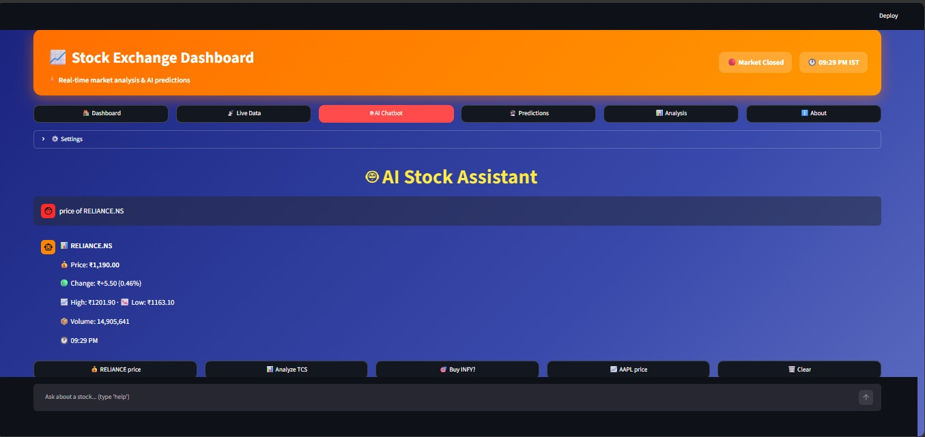
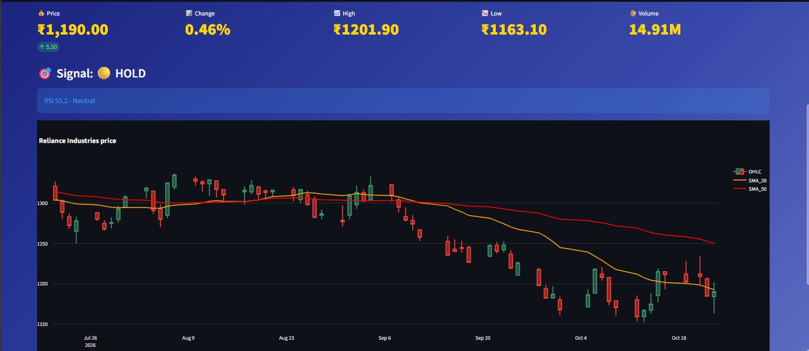

4.RESULT:
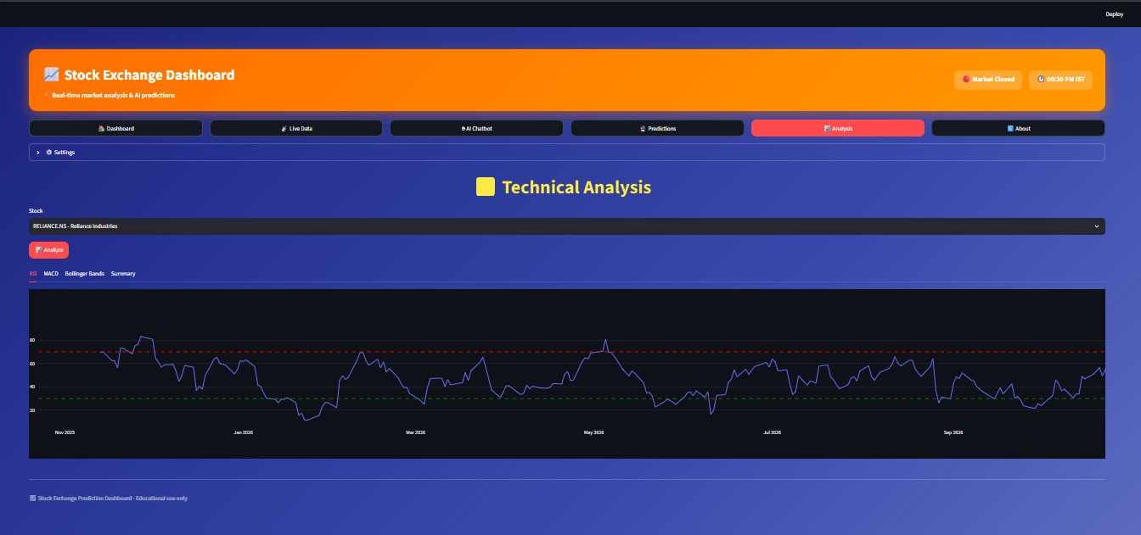
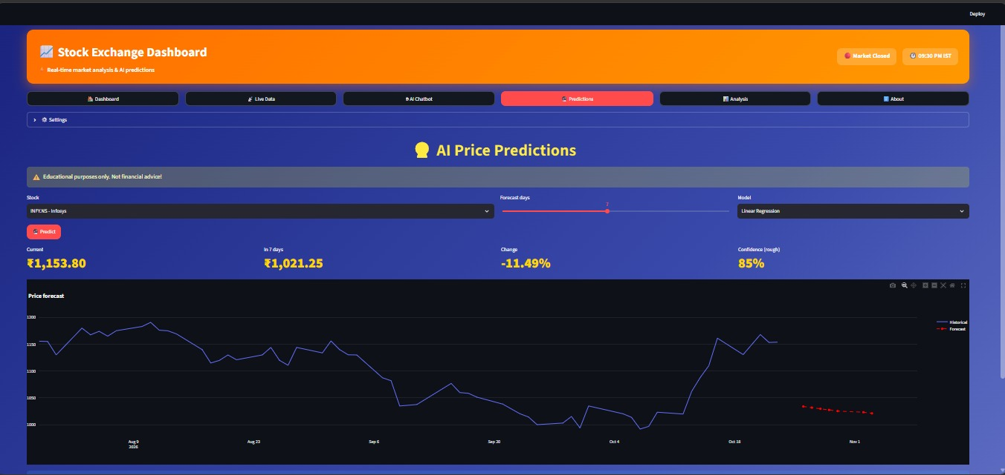



5.CONCLUSION:
1. Core Methodologies for Stock Prediction
Stock market prediction generally combines four main analytical frameworks:
Approach | Primary Focus | Key Inputs & Metrics | Time Horizon
Technical Analysis | Patterns in historical price and volume data | Moving Averages (SMA, EMA), RSI, MACD, Support & Resistance | Short to Medium Term
Fundamental Analysis | Evaluation of intrinsic company value | P/E Ratio, Balance Sheets, Cash Flow, Macro Interest Rates, Inflation | Medium to Long Term
Sentiment Analysis | Market psychology and public reaction | Financial news articles, social media sentiment, earnings call transcripts | Very Short to Short Term
Quantitative & Statistical | Mathematical models & time series forecasting | ARIMA, GARCH (volatility modeling), Monte Carlo simulations, Linear Regression | Custom / Multi-horizon

2. Machine Learning & Predictive Modeling
Modern stock prediction systems use specialized machine learning models to capture complex, non-linear relationships:

A. Time Series & Sequence Models
- LSTM (Long Short-Term Memory Networks): Recurrent neural network architecture widely used for sequence data. It retains long-term dependencies in sequential stock prices to detect temporal patterns.
- ARIMA / SARIMAX: Traditional statistical time series models used as baseline benchmarks for trend and seasonality forecasting.

B. Tree-Based & Ensemble Models
- XGBoost & LightGBM: Highly efficient gradient-boosting decision tree models. They process structured tabular features—such as technical indicators mixed with macroeconomic data—to predict price directional movement (e.g., UP/DOWN classification).

C. Natural Language Processing (NLP)
- Transformer Models (e.g., FinBERT): Pre-trained language models that process unstructured news, SEC filings, and market sentiment to produce quantifiable sentiment scores for predictive feature sets.

3. End-to-End Predictive Pipeline
To construct a predictive model for stock prices, the typical engineering workflow involves:
- Data Ingestion: Collect historical OHLCV (Open, High, Low, Close, Volume) market data, fundamental metrics, and news sentiment.
- Feature Engineering: Calculate technical indicators (e.g., 20-day SMA, 14-day RSI, Bollinger Bands) and compute rolling returns or volatility features.
- Data Preprocessing: Scale/normalize input data (e.g., Min-Max scaling for neural networks) and handle missing data points.
- Model Training & Validation: Train sequential or ensemble models on historical training sets while utilizing walk-forward cross-validation to prevent target leakage.
- Backtesting & Evaluation: Test model predictions against unseen test data using evaluation metrics such as RMSE (Root Mean Squared Error), MAPE (Mean Absolute Percentage Error), or financial metrics like the Sharpe Ratio.

4. Fundamental Limitations & Realities
- Efficient Market Hypothesis (EMH): Weak or semi-strong EMH states that current stock prices already reflect all publicly available information, making consistent market-beating predictions extremely difficult.
- Noise and Volatility: Daily market movements contain significant random noise, non-stationarity, and sudden external shocks (e.g., geopolitical developments, unexpected macroeconomic announcements) that historical models cannot anticipate.
- Overfitting Risk: Machine learning models easily learn patterns specific to historical training data that fail when applied to real-time, unseen market environments.

